OVERVIEW/INTRODUCTION

A. Mission – Vision of Mary Mediatrix Medical Center

B. Institutional Organogram of Mary Mediatrix Medical Center

C. Establishment and Mandate of the MMMC-RERC

D. Principles and Guidelines Guiding the MMMC-RERC

E. Brief History of the MMMC-RERC

Supersedes | Standard Operating Procedure Version 4
Version | 5
Authored By | Dr. Narcisa Sonia Comia  Dr. Mary Warren Ilaga  Dr. Von Andre Medina
Version Date | 08 February 2019
Approved By | Dr. Robert Magsino  President
Approval Date | 08 February 2019

A. MISSION AND VISION OF MARY MEDIATRIX MEDICAL CENTER

OUR VISION

By 2020, we will be:

The leading medical center in the Southern Tagalog Region providing wide range of services imbued with personalized and compassionate ideals and expertise of the highest standards that are anchored on research and trainings.

Our Mission

Mary Mediatrix Medical Center is committed to provide appropriate care to its customers in Southern Luzon through expert medical staff, supported by motivated, well trained and customer-focused personnel. We aim to deliver services enabled by reliable medical facilities, advanced technologies and efficient processes that are anchored on our core values. Our goal is to ensure sustainability to help address the healthcare needs of the nation.

B. INSTITUTIONAL ORGANOGRAM OF MARY MEDIATRIX MEDICAL CENTER

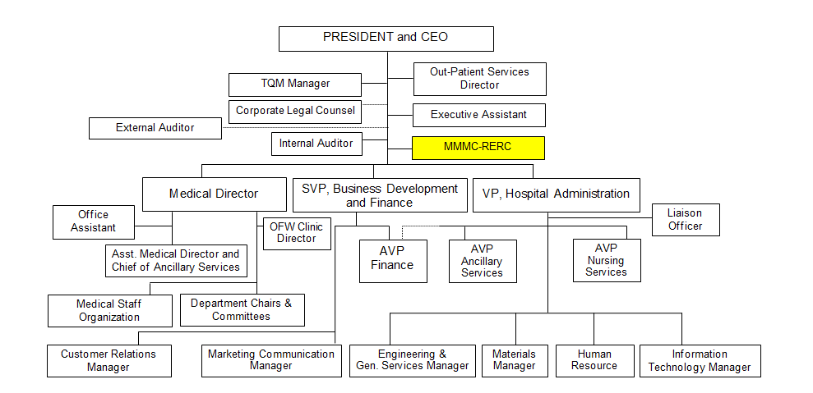

RERC ORGANIZATIONAL CHART

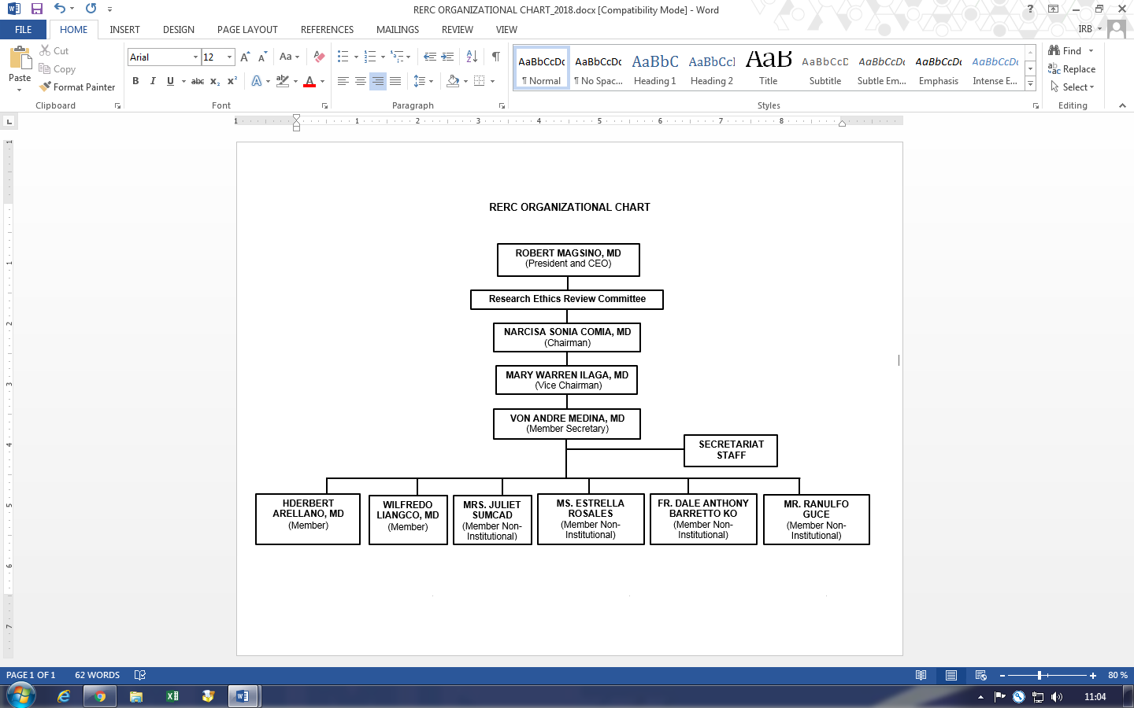

C. ESTABLISHMENT AND MANDATE OF THE MARY MEDIATRIX MEDICAL CENTER-
RESEARCH ETHICS REVIEW COMMITTEE (MMMC-RERC)

The MMMC-RERC is an independent body created by the MMMC under the President of the Hospital, whose responsibility is to ensure the protection of the rights, safety and well-being of human subjects involved in health related research and to provide public assurance of that protection. In accordance with applicable national / international regulations, the MMMC-RERC has the authority to approve, require modifications to, or disapprove research protocols and related documents as well as to ensure compliance with its relevant procedures after approval.

The MMMC-RERC review and monitor health researches that involve:

- MMMC patients, done within the MMMC, or using MMMC facilities, including those initiated by MMMC active, associate active, and visiting staff, residents/fellow in training and other hospital staff.
- Pharmaceutical industry sponsored research using MMMC facilities, MMMC patients in cooperation with MMMC active/associate active/visiting staff.
- MMMC-RERC may review protocols from outside the MMMC provided it is within the expertise of MMMC.

This SOP provides the Terms of Reference (TOR) that describe the framework for the constitution of the MMMC-RERC, the responsibilities and activities of its officers, members, and staff.

RESPONSIBILITIES

It is the responsibility of MMMC President to constitute and establish the MMMC-RERC. The President is responsible for appointing the MMMC-RERC Chair, Vice-Chair, Member-Secretary, Secretariat Staff, and Members. He is also responsible for providing the terms of reference for these appointments in accordance with prevailing hospital policies, guidelines, and regulations.

It is the responsibility of the MMMC-RERC Chair, Vice-Chair, Member-Secretary, Secretariat Staff and Members to study, comprehend, comply and respect the procedures and guidelines set forth by the MMMC-RERC.

It is the responsibility of the newly appointed MMMC-RERC Chair and members to read, understand, respect, and sign the required appointment forms at the start of their appointment or reappointment to the RERC. Refusal of any member to sign such agreement may be ground for his/her disqualification from the Committee.

It is the responsibility of newly appointed MMMC-RERC members and staff to undergo training during the course of his appointment. The existing MMMC-RERC members and staff should continuously update themselves and train on relevant knowledge and skills. The MMMC-RERC Chair shall enjoin MMMC-RERC members and staff to attend trainings/seminars/workshops as needed, and ensure that adequate resources are provided for continuing professional development. Therefore MMMC is responsible for allocating an annual budget for specific trainings and other educational activities for MMMC-RERC members and staff.

D. PRINCIPLES AND GUIDELINES GUIDING THE MMMC-RERC

ETHICAL BASIS

The MMMC-RERC is guided in its reflection, advice, and decision by the ethical principles and procedures expressed in the following international guidelines and documents:
- Declaration of Helsinki (2013 and subsequent revisions)
- CIOMS 2002, 2009 and 2016

The RERC will function in accordance with national laws, regulations, and guidelines, including PNRHS Act of 2013 and NEGHR 2011, FDA Circulars and other laws.

The RERC provides its own standard operating procedures based on:

- Operational Guidelines for Ethics Committees that Review Biomedical Research (2000) by the World Health Organization (WHO)
- Standards and Operational Guidance for Ethics Review of Health-Related Research with Human Participants (2011) by the World Health Organization (WHO)
- National Ethical Guidelines for Health-related Research 2017
- International Conference on the Harmonization of Good Clinical Practice (ICH-GCP 1996)
- International Conference on Harmonization of Technical Requirements for registration pharmaceuticals for human use ; Integrated Addendum to ICH E6(R1) Guideline for Good Clinical Practice E6(R2) Current step version dated 09 November 2016
- Council for International Organizations of Medical Sciences (CIOMS) in collaboration with the world Health Organization (WHO) 2016
- National Ethical Guidelines for Health Research (2011) by the Philippine Health Research Ethics Board (PHREB)
- Food and Drug Administration Philippines (FDA) Guidelines Regulation of Clinical Trials in the Philippines (2012)

The RERC adheres to national and international ethical standards and recognizes that the protocols it approves may also be approved by national and/ or local ethics committees prior to their implementation in specific localities.

In evaluating protocols and ethical issues, the RERC is cognizant of the diversity of laws, cultures and practices governing health research in various countries around the world.

It attempts to inform itself, whenever possible, of the regulations and requirements of sponsor countries conducting global protocols in the Philippines; and of the requirements and conditions of various localities where a proposed MMMC research is being considered.

The RERC will take the initiative to be informed, as appropriate, by national / local ethics committees and researchers of the impact of the research that it has approved.

E. BRIEF HISTORY OF THE MMMC-RERC

Mary Mediatrix Medical Center- Research Ethics Review Committee formerly Institutional Review Board/ Research Ethics Committee was established on 2007. Dr. Robert Magsino, the President and CEO (former Medical Director) of Mary Mediatrix Medical Center (MMMC), appointed Dr. Narcisa Sonia Comia to be the Chair of the Research Ethics Committee. Having no experience at all in Research Ethics, she was assisted by Dr. Tito Atienza, a seasoned investigator at Veterans Memorial Medical Center.

Mr. Jherrist Gorayeb, head of the marketing department of MMMC that time, but a nurse by profession was the first recruited member. Since there should be at least five (5) members, Dr. Narcisa Sonia Comia invited a male pediatrician, a female cardiologist, a retired engineer and a former member of the Good Samaritan to complete the team. The ethics committee was then called MMMC Institutional Review Board (IRB). There was no office, no secretariat and definitely no Standard Operating Procedure to guide them. To aid the need for secretariat staff as well as the office, Ms. Sheryl Paradero, the secretariat staff of the Department of Medicine, was requested to also serve as the secretariat of the IRB. During that time, IRB shared an office and equipment with the Department of Medicine.

During its first year of existence, one protocol was received and approved. In the next few years, more pharmaceutical-sponsored research protocols were submitted and approved by MMMC-IRB. The members increased to seven (7).

One time, as informed by Dr. Tito Atienza, Japanese auditors came to do a site visit at Mary Mediatrix to check how MMMC-IRB functions, where and how files are being kept and how many members MMMC-IRB have. In preparation for their visit, an office was thus given to IRB equipped with a desktop computer and cabinets with locks and keys.

Later on, more and more protocols were submitted. By 2011, MMMC-IRB already had a Chairman, a Vice-chair, a Member-Secretary, four members and a full-time secretariat. For the creation of the SOP, an SOP workshop was attended by the Chair, Vice-Chair and Member- Secretary. By the last quarter of 2012, the first version of SOP was approved by the President, Dr. Robert Magsino. Another SOP workshop was attended in March 2014 and towards the end of August 2014, SOP version 2 was submitted to the President for approval.

Since the formation of the MMMC-IRB, it has approved more than sixty (60) industry-sponsored clinical trials and to date we still have thirty four (34) ongoing trials.

The name MMMC-IRB has been replaced by MMMC- Research Ethics Review Committee (RERC). Currently, RERC is composed of nine (9) members.

MMMC-RERC was granted first granted PHREB level III accreditation and FERCAP recognition in 2015. Three years later, in August 2018, our second accreditation visit took place. MMMC-RERC was granted its second FERCAP recognition in November 2018.

As of September 2018, MMMC-RERC has approved more than eighty (80) industry sponsored and 27 of them are still on-going. We have also approved more than 32 research papers initiated by college students, medical residents in training and fellows in training.

